**Learning My Address**

Children should know the address of where they live and a phone number where they can reach a parent.

Practice saying the address and phone number is needed. A fun way to learn these is to put them in a song.

This can be sung to the tune of Row, Row, Row Your Boat, but feel free to use whatever tune you like and make up your own words, too!

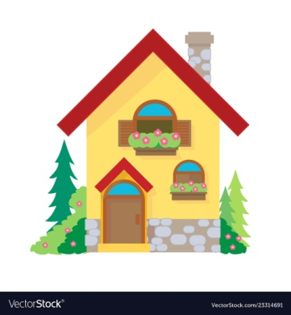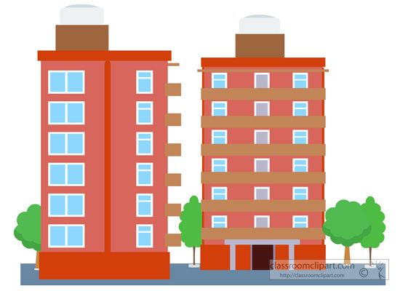My Address tells me where I live

The numbers and the street,

I can get there in a car,

Or walking on my feet!

(*Example)* I live at number 123 that is on High Street

I live in Orange, that’s the town,

New Jersey is the state.

A Good song for learning a phone number is Frere Jacques. You remember the song:

Frère Jacques,  Frère Jacques   
Dormez-vous?  Dormez-vous?

For a phone number: *(Example)*

You sing: 567

Your child repeats: 567

You sing: 978

Your child: 978

You sing: 3564

Your child: 3564

You sing: Green means go

Your child: Green means go

(this is referring to the go button that is on a cell phone, since this is what most people use.)

You may want to allow your child to practice on an old cell phone.